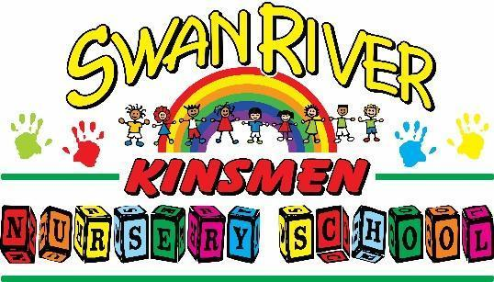

SWAN RIVER KINSMEN NURSERY SCHOOL
JOB POSTING

POSITION: CHILD CARE ASSISTANT (PART-TIME)
LOCATION: SWAN RIVER, MB
START DATE: JANUARY 2025
APPLICATION DEADLINE: OPEN UNTIL FILLED

Established in 1982, the Swan River Kinsmen Nursery School (SRKNS) is a non-profit nursery school for children ages three and four years old. We are an inclusive school, welcoming students and families looking for a great start before kindergarten. The school operates Tuesday through Friday, from September to June, with (2) three-hour classes per day (three-year-olds in the morning and four-year-olds in the afternoon). We follow the Swan Valley School Division calendar for holidays and summer vacation. Mondays are paid prep and administration days.

The Swan River Kinsmen Nursery School is actively looking for a Child Care Assistant to support current staff to help with care in the school.

The successful applicant will have prior experience in child care, the ability to handle competing priorities, and skills to manage challenging behaviors with ease. This role is a fit for someone with a love for children, who will play an important role in maintaining a supportive and encouraging environment for both students and parents.

Roles & Responsibilities
- Provide vigilant and compassionate care to the children at the school.
- Contribute to a safe, happy, healthy, and stimulating environment for children.
- Help to execute engaging indoor and outdoor activities for children.
- Maintain a positive working relationship with other Swan River Kinsmen Nursery School staff, board, parents, and community members.
- Light housekeeping duties to ensure a clean, organized space.

Skills & Qualifications
- 40 hour CCA course (prefer that this has been completed).
- Satisfactory criminal record and child abuse registry check.
- First aid/CPR training.
- Previous child care experience.
- Enthusiasm to work with children.
- Ability to multi-task and manage challenging behaviours effectively.
- Strong communication and interpersonal skills.
- Exceptional organizational, problem-solving, and time-management skills.
- Friendly, approachable, and patient demeanour.

Hours: 12 hours guaranteed in the afternoons Tues-Fri, and substituting for full-time staff members as needed. Opportunities for future growth in the position.
Salary commensurate on experience and qualifications, but adheres to standards set forth by the Manitoba Government (Early Learning and Child Care Wages).
How to Apply
Please send your resume and a brief paragraph on why you would like to be considered to board.swanrivernurseryschool@gmail.com. While we thank all candidates for their interest, only those selected for an interview will be contacted.

